LIGHT THE WORLD SERVICE PROJECT
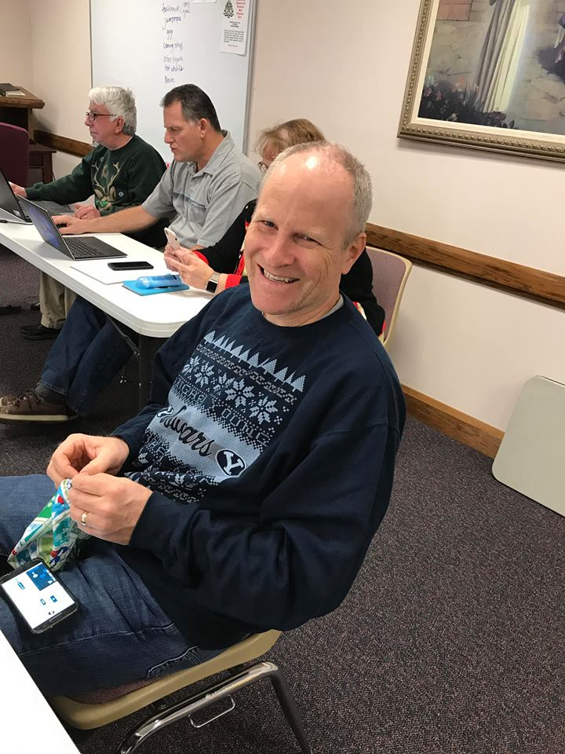  Bro. Watts | 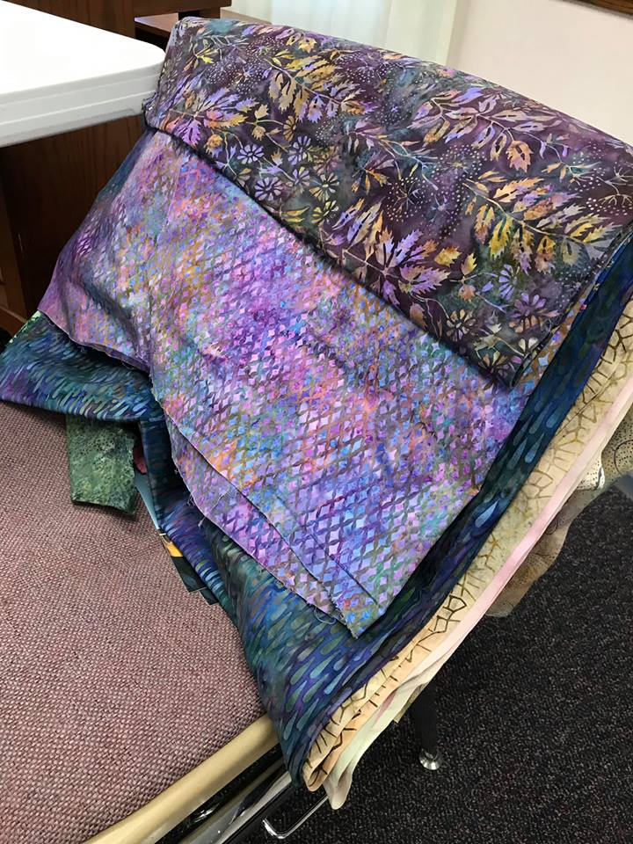  Fabric for hygiene bags

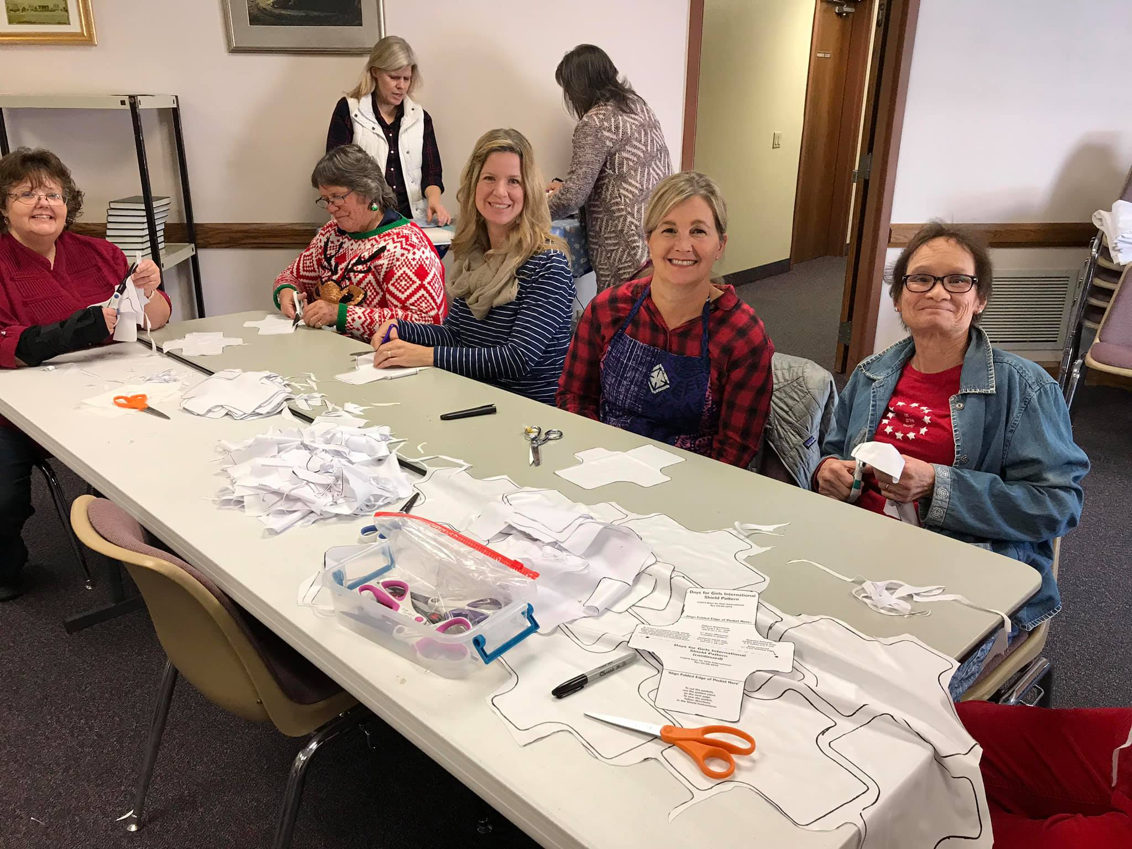
Left to Right: Inge Carter, Diane Workman, Krista Watts (behind), Debbie Rice, Susan Manning, Marla Emerson

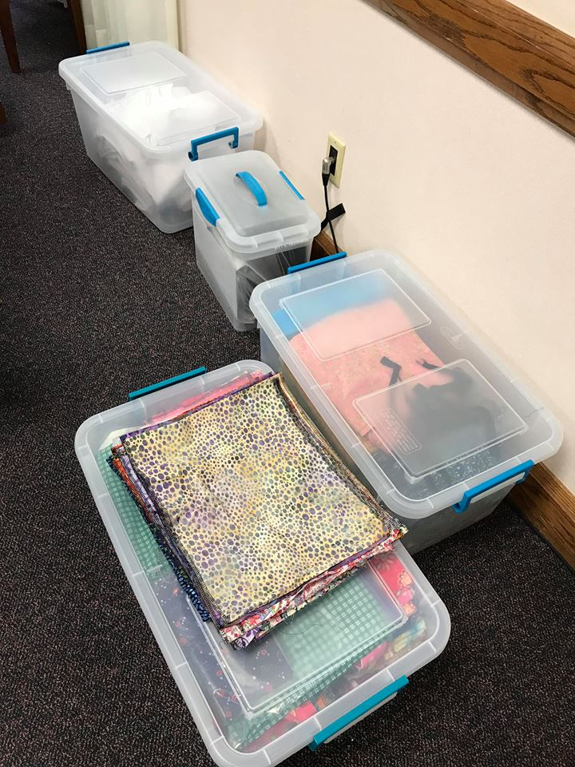  Bins of fabric and completed hygiene supplies | 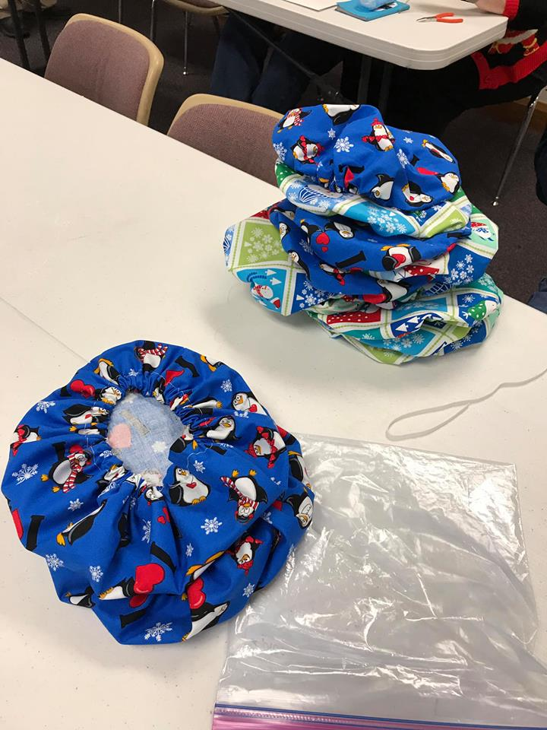  Surgical caps for Renown Hospiral
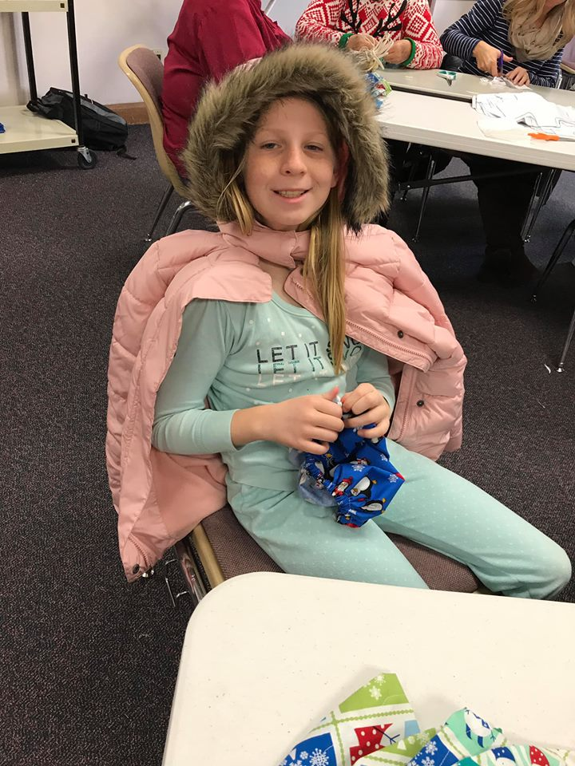  Young sister Watts contentedly threading elastic into a surgical cap | 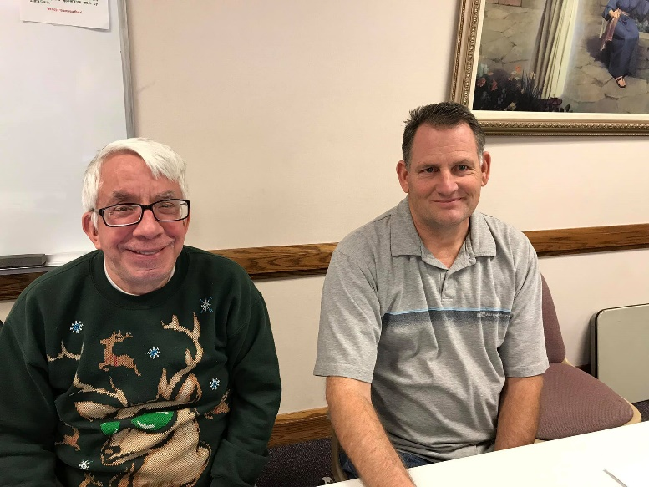  Two husbands work on family history while their wives work on service projects

