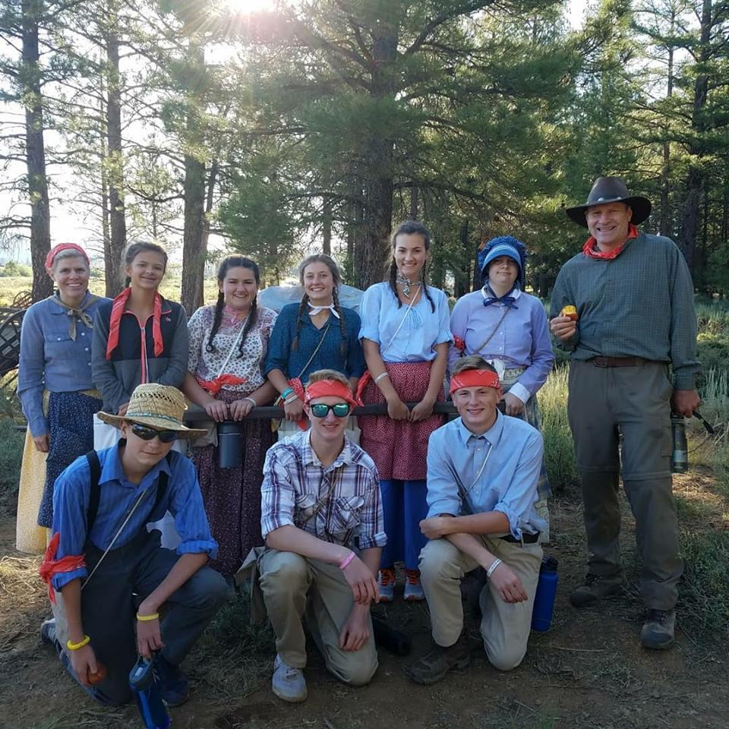
Trek Family: Krista Watts, Kalyn, Chelsey, Brooklyn, Kaylee, Alex, Bro. Watts, Bro. Reno, Ethan, Derek

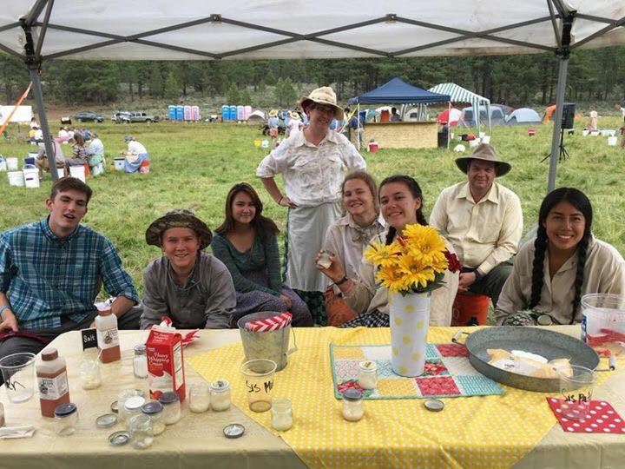
Second Trek Family about to snack: Noah, Kaden, Alair, na, Rilee, Megan, na, Melanie

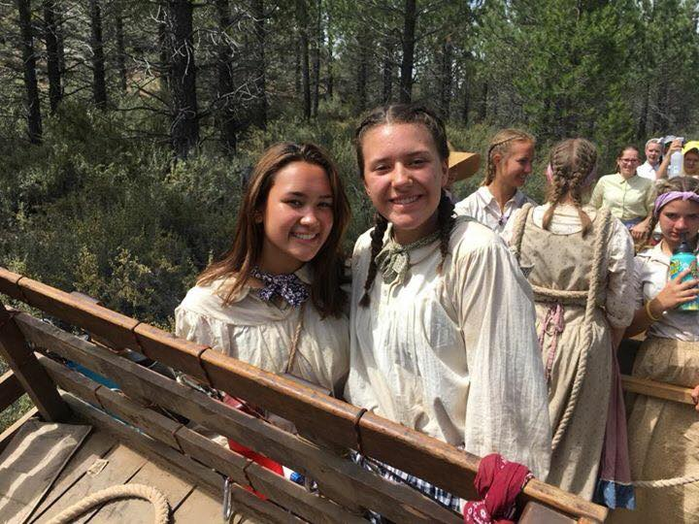
Alaire and Megan lookin’ gorgeous

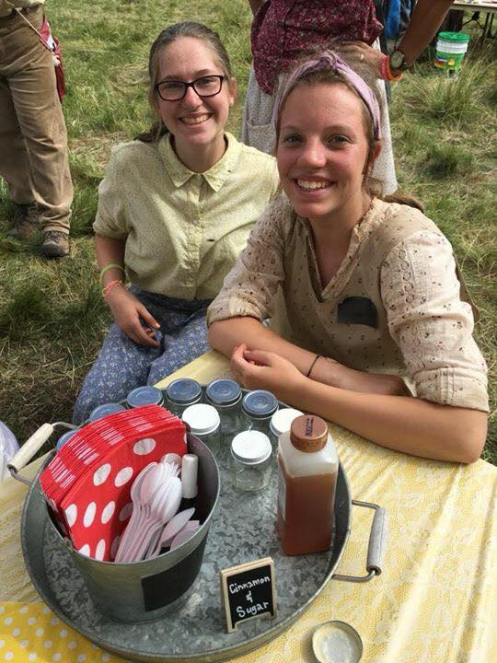
Emma and, Celeste (a.k.a. Cinnamon & Sugar)
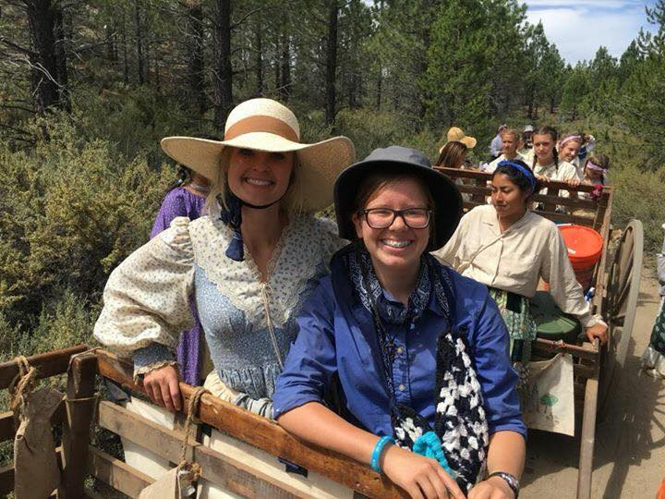
Valerie Page and Rachel causing a traffic jam

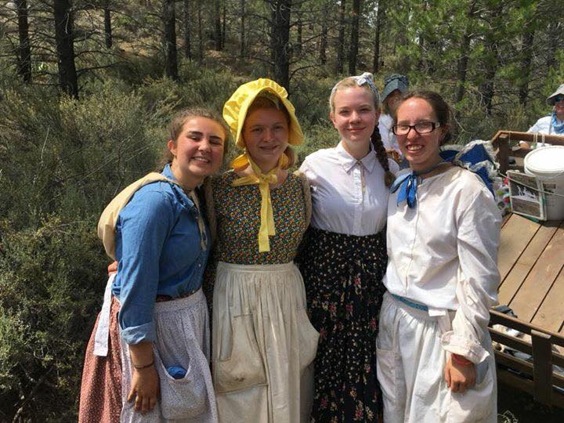
Cambria, na, na, Hannah: friends helping friends
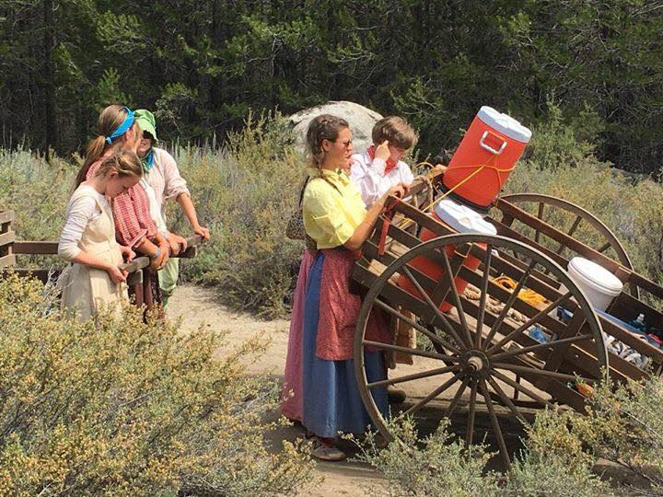
Kaylee & Alex thinking about that rock up ahead

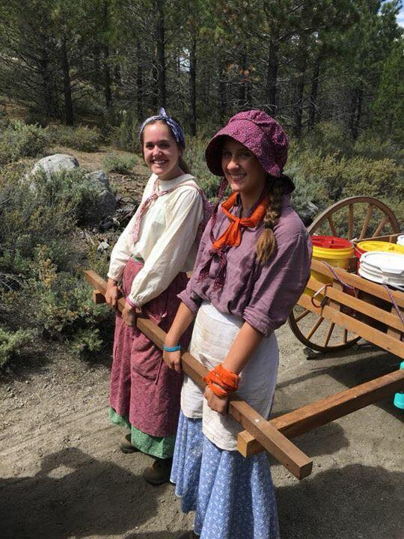 Liz, Alyssa doing pull-ups
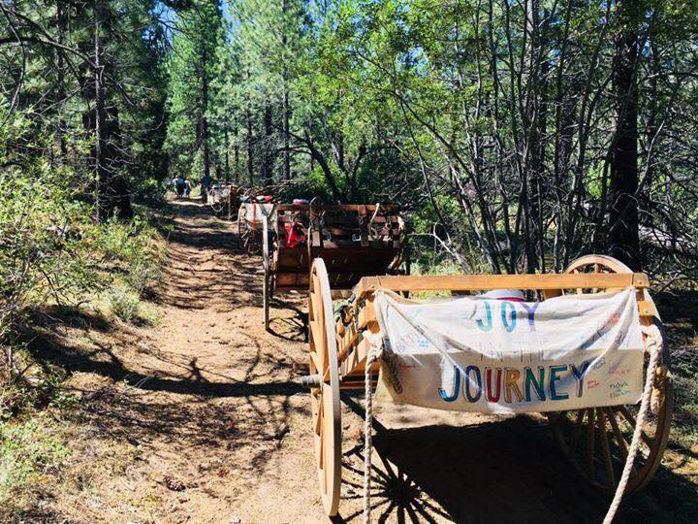
No parking meters here
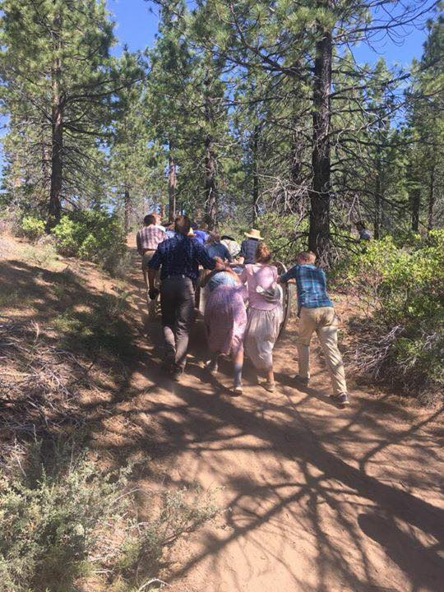 Put your shoulder to the wheel, push along.

